13.91: a)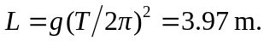 b)There are many possibilities. One is to have a uniform thin rod pivoted about an axis perpendicular to the rod a distance d from its center. Using the desired period in Eq. (13.39) gives a quadratic in d, and using the maximum size for the length of the rod gives a pivot point a distance of 5.25 mm, which is on the edge of practicality. Using a “dumbbell,” two spheres separated by a light rod of length L gives a slight improvement to d=1.6 cm (neglecting the radii of the spheres in comparison to the length of the rod; see Problem 13.94).

